Week 3-1

[**Operators and Expressions, Managing Input and Output Operations**](http://www.rajalakshmicolleges.org/moodle/course/section.php?id=4)

Roll no: 240801137

Name: Jhanani .M

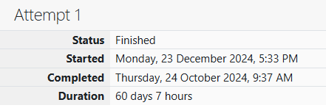

**Problem 1:**

Write a program to read two integer values and print true if both the numbers end with

the same digit, otherwise print false. Example: If 698 and 768 are given, program should

print true as they both end with 8. Sample Input 1 25 53 Sample Output 1 false Sample

Input 2 27 77 Sample Output 2 true

**Code**

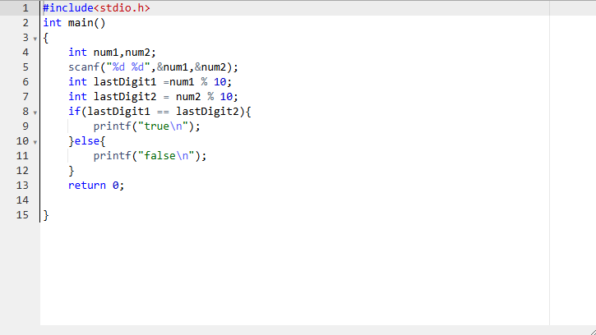

**OUTPUT:**

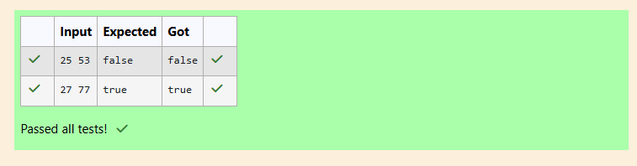

**Problem 2:**

In this challenge, we're getting started with conditional statements.

Task

Given an integer, n, perform the following conditional actions:

· If n is odd, print Weird

· If n is even and in the inclusive range of 2 to 5, print Not Weird

· If n is even and in the inclusive range of 6 to 20, print Weird

· If n is even and greater than 20, print Not Weird

Complete the stub code provided in your editor to print whether or not n is weird.

**Input Format**

A single line containing a positive integer, n.

**Constraints**

· 1 < n < 100

**Output Format**

Print Weird if the number is weird; otherwise, print Not Weird.

**Sample Input 0**

3

**Sample Output 0**

Weird

**Sample Input 1**

24

**Sample Output 1**

Not Weird

**Explanation**

Sample Case 0: n = 3

n is odd and odd numbers are weird, so we print Weird.

Sample Case 1: n = 24

n > 20 and n is even, so it isn't weird. Thus, we print Not Weird.

**Code :**

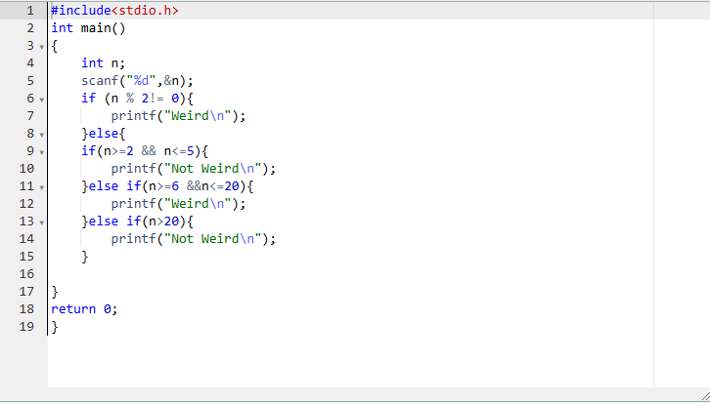

**OUTPUT:**

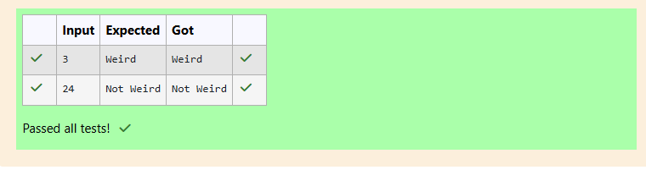

**Problem 3:**

Three numbers form a Pythagorean triple if the sum of squares of two numbers is

equal to the square of the third. For example, 3, 5 and 4 form a Pythagorean triple, since

3*3 + 4*4 = 25 = 5*5 You are given three integers, a, b, and c. They need not be given in

increasing order. If they form a Pythagorean triple, then print "yes", otherwise, print "no".

Please note that the output message is in small letters. Sample Input 1 3 5 4 Sample

Output 1 yes Sample Input 2 5 8 2 Sample Output 2 no

**Code:**

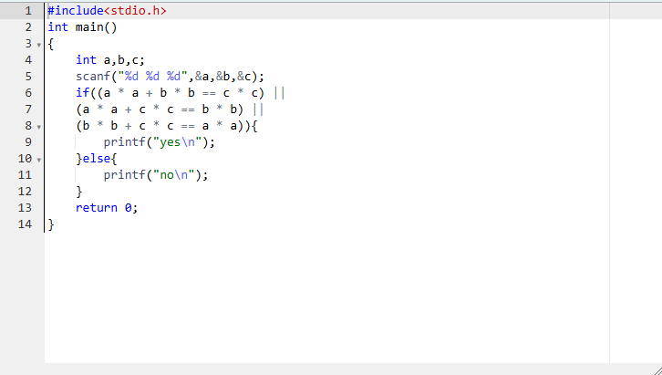

**OUTPUT:**

